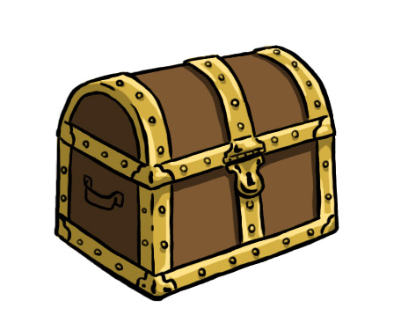
Print this page and bring to school. Your child will receive a treasure box pick because you visited our website!

Name:_______________

